Spotting light

John has lost his pet cat in the dark.
He uses a torch to find it in his garden.

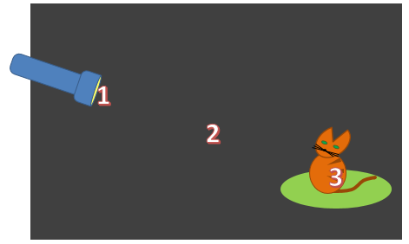

Where is there light?
Put a tick (✓) in the box next to the best answer.
A | 1, 2 and 3
B | 1 and 3 only
C | 1 only
D | 3 only

Physics > Big idea PSL: Sound, light and waves > Topic PSL1: Sound and light > Key concept PSL1.2: Characteristics of light
Diagnostic question
Spotting light

Overview
Learning focus: | Light travels in straight lines at very high speeds.
Observable learning outcome: | Describe how light travels in straight lines.
Question type: | Simple multiple choice
Key words: | Light, travel, straight-line

P | PRIOR UNDERSTANDING  This diagnostic question probes understanding of ideas that are usually taught at age 5-11, to aid transition from earlier stages of learning.

What does the research say?
Most 10 and 11 year olds think that light is found only in bright areas and not in the space between, for example, a source of light and the patch of light it makes (Guesne, 1985; Allen, 2014). This may be because when students think of light, they do not necessarily think of it as travelling. They may instead think of rays as like ‘wires of light’ or roads going from A to B (Driver et al., 1994).
These misunderstandings are often key stumbling blocks to students’ understanding of light, which are rarely considered in teaching schemes. This question checks whether students understand that light travels through the air (the space between source and illuminated spot).
Ways to use this question
Students should complete the question individually. This could be a pencil and paper exercise, or you could use an electronic ‘voting system’ or mini white boards and the PowerPoint presentation.
The answers to the question will show you whether students understood the concept sufficiently well to apply it correctly.
If there is a range of answers, you may choose to respond through structured class discussion. Ask one student to explain why they gave the answer they did; ask another student to explain why they agree with them; ask another to explain why they disagree, and so on. This sort of discussion gives students the opportunity to explore their thinking and for you to really understand their learning needs.
Differentiation
You may choose to read the questions to the class, so that everyone can focus on the science. In some situations it may be more appropriate for a teaching assistant to read for one or two students.

Equipment
For a demonstration (optional)
- Water in a spray bottle to produce a fine mist
- Powerful torch
- Dim room
Expected answer
Answer A
How to respond - what next?
Light is travelling from the torch, through the air and to the cat.
All the other answers treat light as a material or object that is transported from the torch to the cat.
If students have misunderstandings about light continually travelling through the air whilst the torch is on, it can help to demonstrate that this is the case with a fine spray of water onto a bright torch beam in a dim room. Light travelling in the beam shows up as it reflects off the water droplets.
The following BEST ‘response activity’ could also be used in follow-up to this diagnostic question:
- Response activity: Laser shadow
Acknowledgments
Developed by Peter Fairhurst (UYSEG).
Images: UYSEG
References
Allen, M. (2014). Misconceptions in Primary Science, Second edn Berkshire, UK: Open University Press.
Driver, R., et al. (1994). Making Sense of Secondary Science: Research into Children's Ideas, London, UK: Routledge.
Guesne, E. (1985). Light. In Driver, R., Guesne, E. & Tiberghien, A. (eds.) Children's Ideas in Science. Milton Keynes: Open University Press.

